Curriculum Vitae

Prof.dr.ir. Ad H.M. Verkooijen (1944)

From 1995 until now professor of power technology
From 2005 until 2009 director department of Energy Technology
From 2004 until 2009 chairman of the department of Materials Science and Engineering.
From 1996 until 2004 director of the Interfaculty Reactor Institute
From 1987 until 1995 research director at KEMA( the research and support organization for the Dutch Electricity Utilities

Some of his other duties:
Member of the Technical Advisory Board of Electrabel ( GDF-SUEZ) an international utility
Vice chairman of the External reactor Safety Committee of Borssele Nuclear Power Station,
Member of “Technical and Scientific Committee” of EURATOM
From 1998 until 2012 director of the Executive Master of Business in Energy Systems of Delft TopTech.
From 1993 until 1996 secretary general of International Electric Research Exchange

Inspector for the International Atomic Energy Agency (IAEA) for nuclear research reactors: Iran and Phillipines.
.
Member of the steering committees of the post Fukushima Complementary Safety Assessments of the Borssele Nuclear Power Station and the High Flux Reactor in Petten.

Contact details:
Prof.dr.ir. Adrian H.M. Verkooijen
Faculty of 3ME
Leeghwaterstraat 44
2628CA Delft
The Netherlands
email: A.H.M.Verkooijen@TUDELFT.NL
email privé: AHMVerkooijen@cs.com
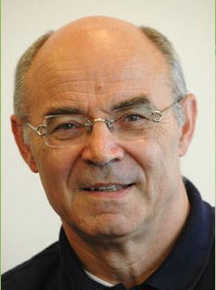

Recent publications on
Gasification of biomass in circulating fluidized bed
kinetics of conversion and of NOx and tar formation
Characterisation of biomass
Cleaning of product gas from biomass gasifier
CFD and electrochemical modelling of Solid Oxide Fuel Cell
System analysis of decentralised power generation with biomass
Pre-combustion carbon capture: system improvement
Design of multiple effect super-heated steam dryer for wet solid fuels
CFD analysis of nuclear reactor cooled with natural circulation of liquid metal
Dynamic modelling of high temperature nuclear gas turbine
Journals:
Biomass conversion & Biorefinery
Industrial & Engineering Chemistry Research
Energy & Fuels
International Journal of Chemical Reactor Engineering
Fuel Processing Technology.
Journal of Power Sources.
Industrial & Engineering Chemistry Research
Journal of Engineering for Gas Turbines and Power
Journal of Power and Energy
Patents on:
Production of artificial kidneys
Processes for power generation
Processes for synthesis of ethane

